New Furniture for St Giles’

Our pews came from St Luke’s Old Street. Over the years they have got increasingly rickety and need to be replaced. After trying out different designs, we have chosen stackable benches and matching chairs with arms for those who need more support.
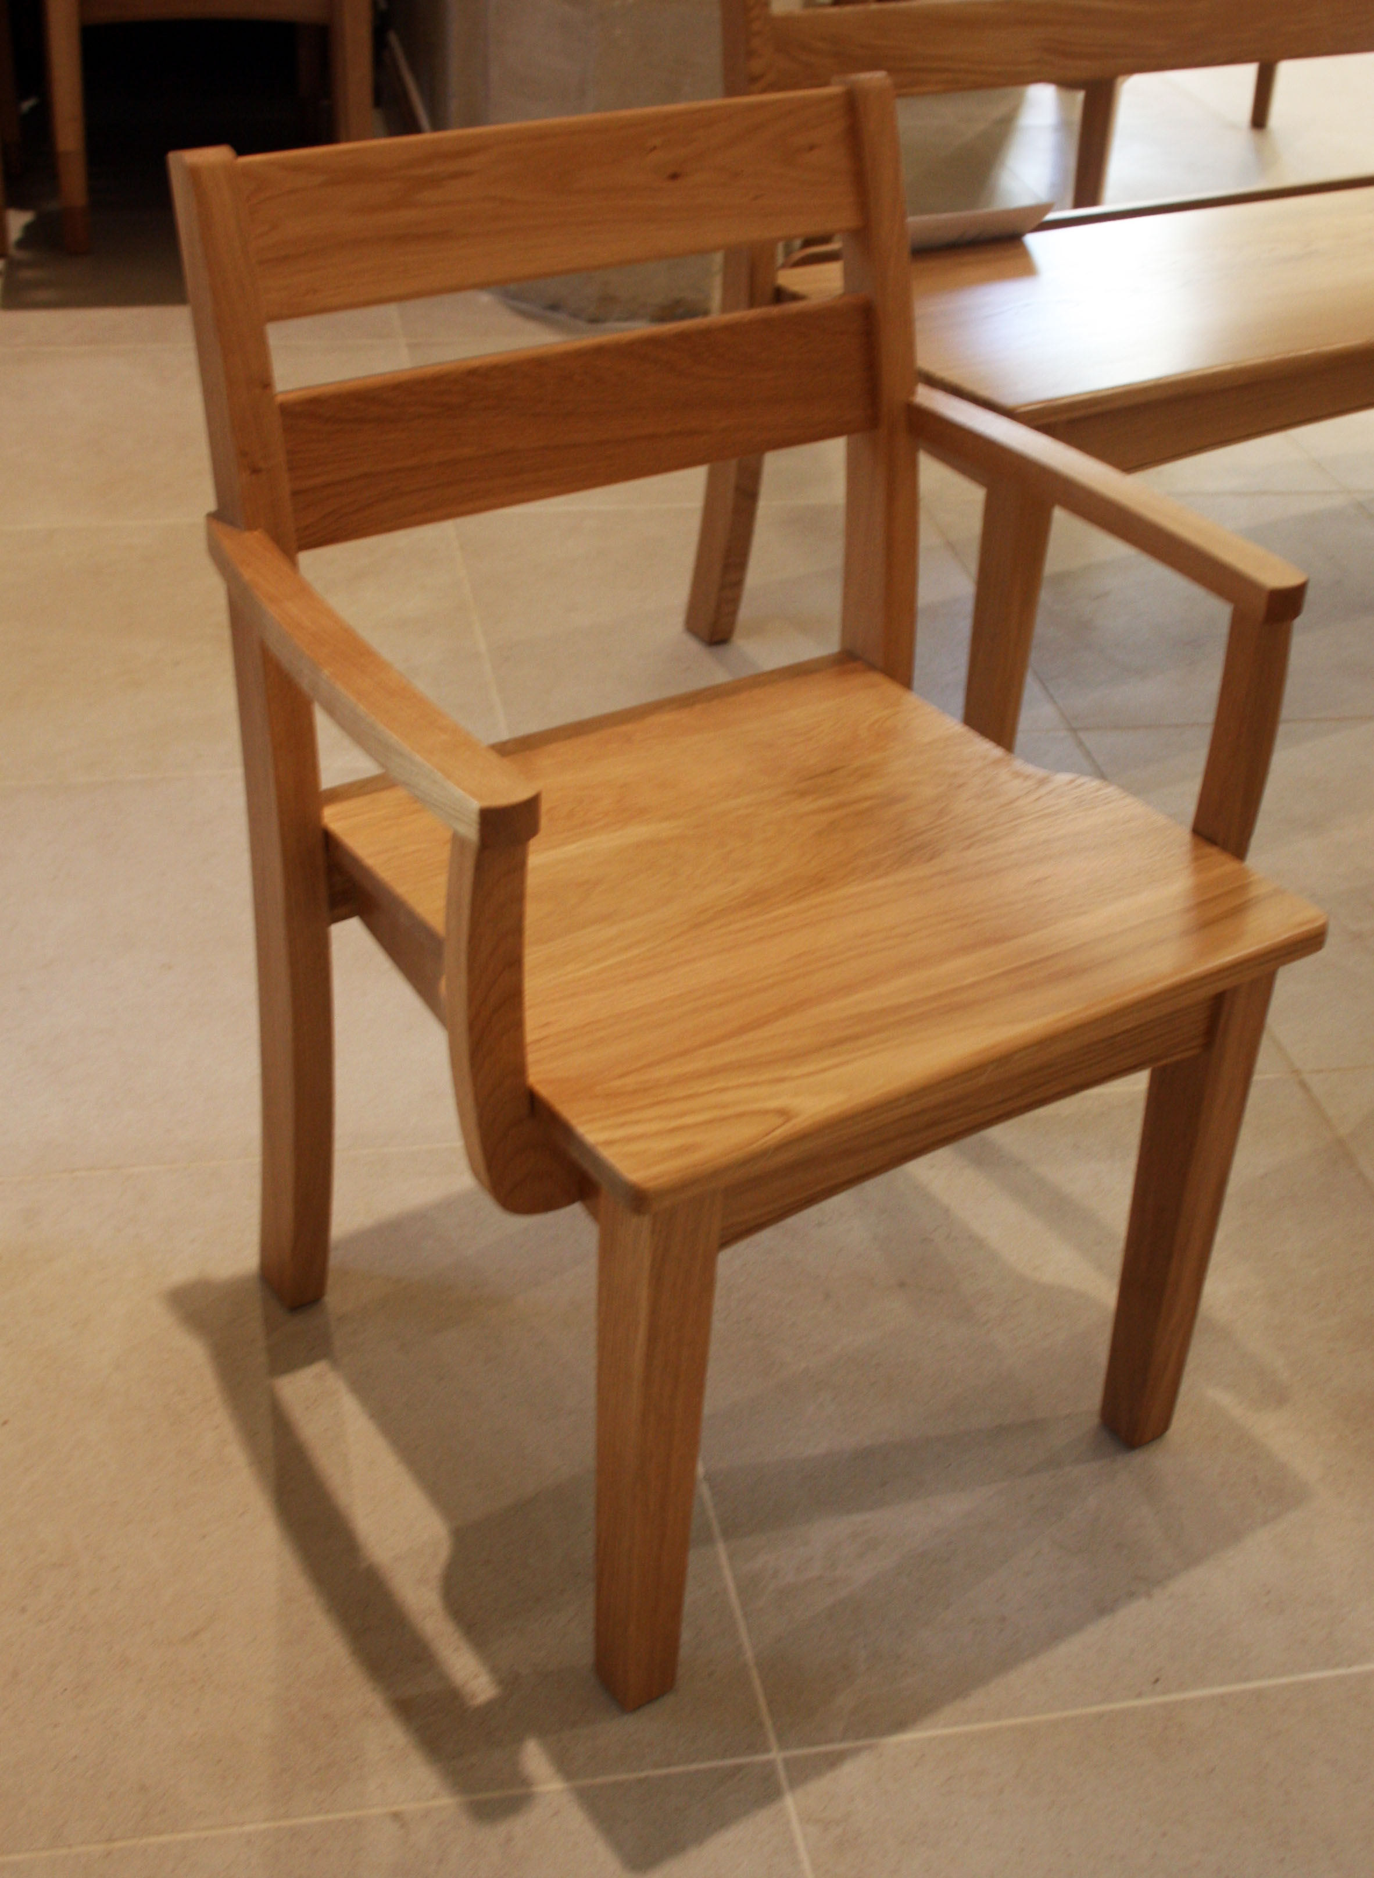
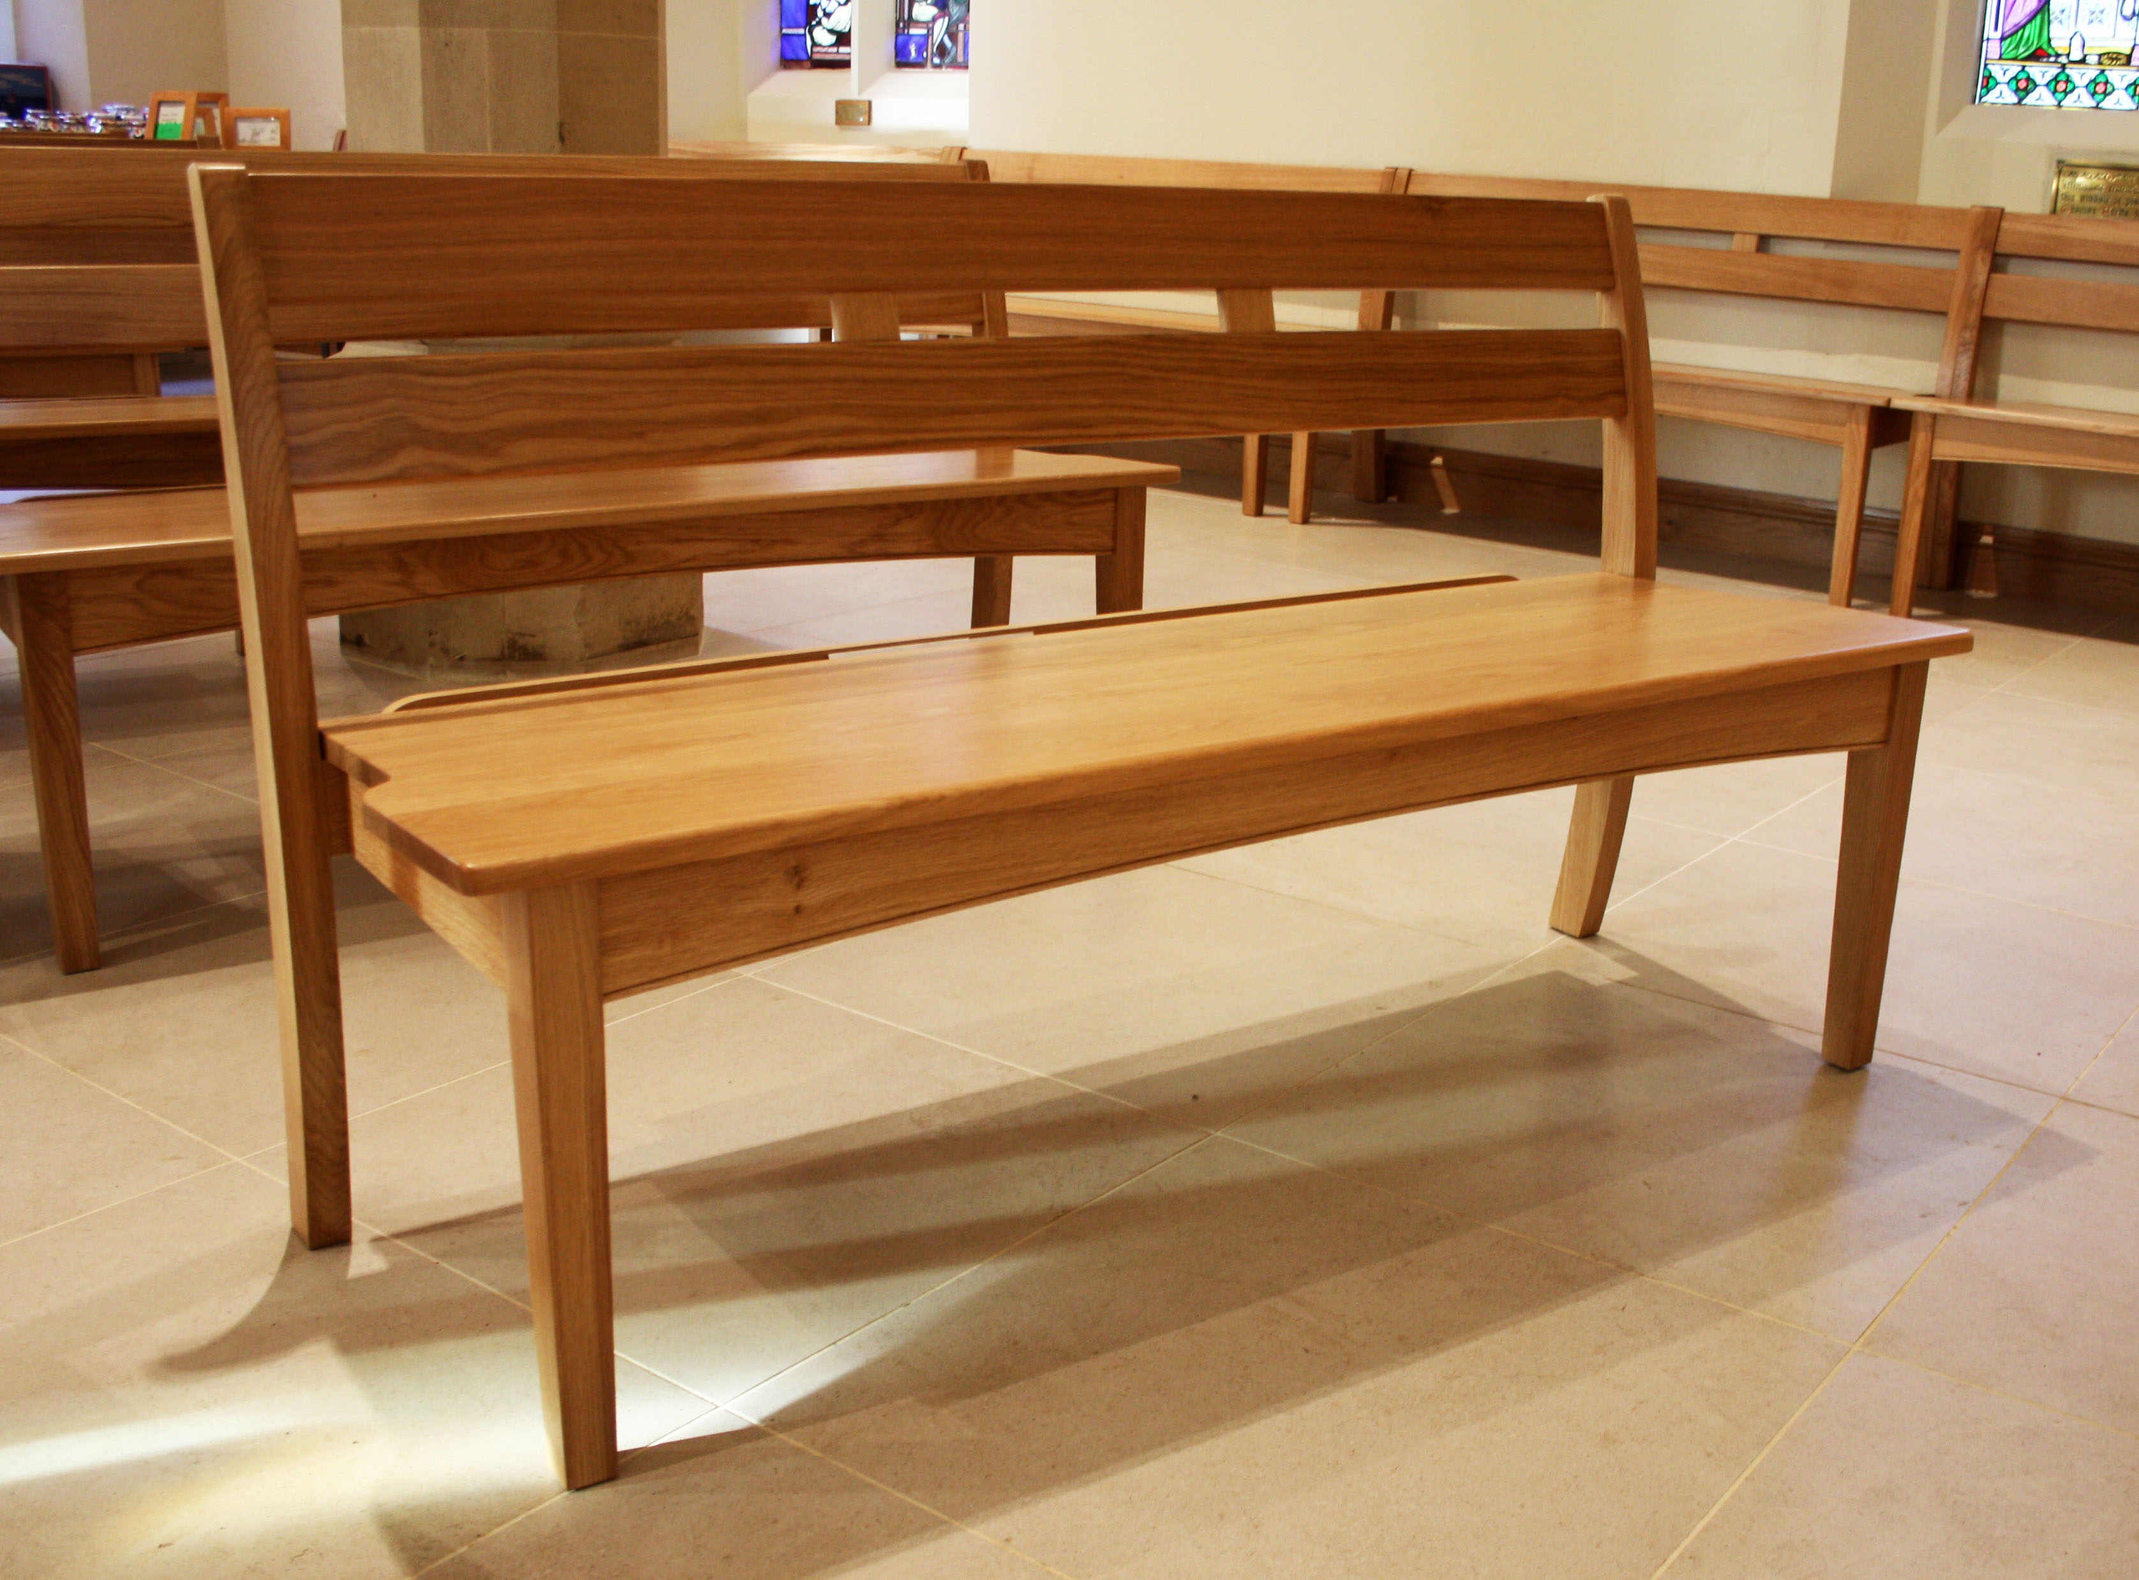

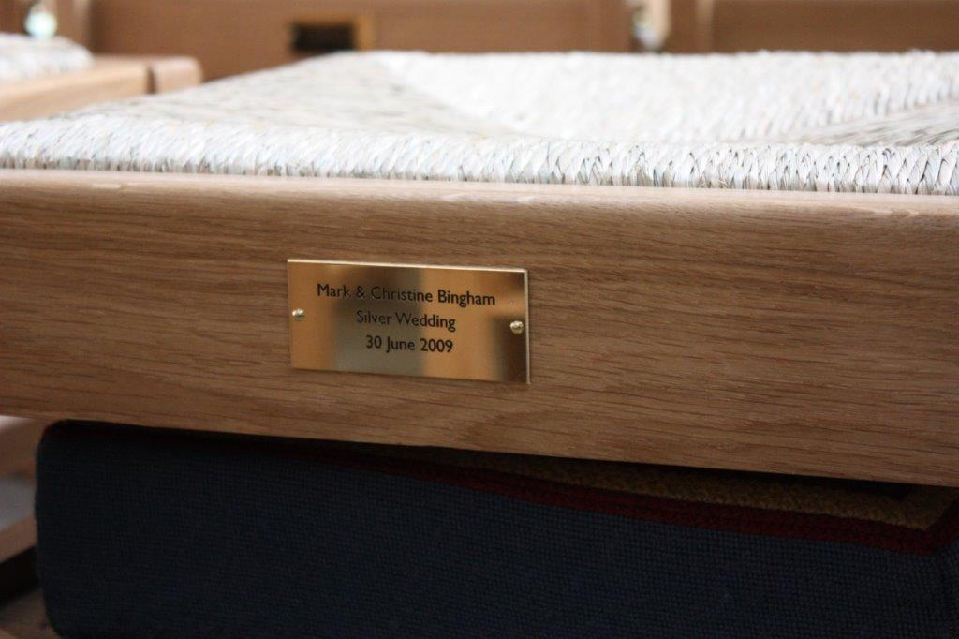
If you would like to commemorate a significant event, a birth, a marriage or the death of a loved one, or join with us in caring for the church in the heart of the Barbican, please make a donation. All donations gratefully received. £1,000 will provide a bench and £500 a chair.
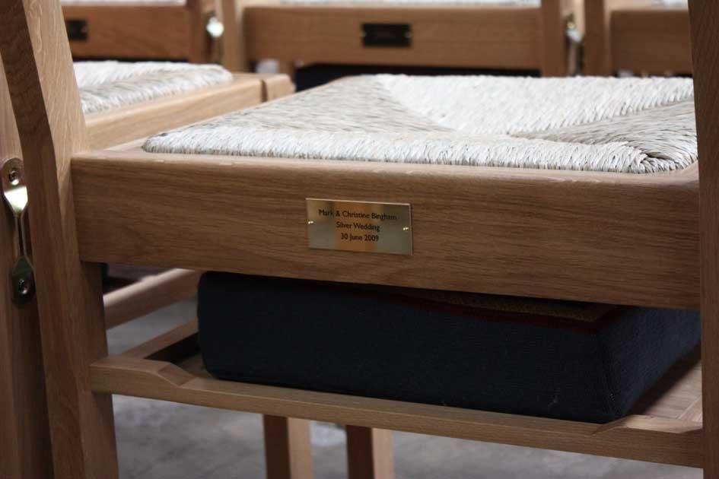

A dedication plaque on the bench or chair will record your gift. We will be holding an evening reception to thank you and celebrate our newly furnished church.

We do hope that you are able to support this appeal. Thank you

New Furniture for St Giles’
Donation form

Your details
Your name(s)
Address

Postcode
Email
Telephone

Your donation
Please tick the relevant box or boxes.

- I/we would like to make a donation of £________ towards New Furniture for St Giles’.

- I/we would like to make a donation of £500 for the purchase of a chair.

- I/we would like to make a donation of £1,000 for the purchase of a bench.

- I/we would like a dedication plaque with the following wording to be attached to the bench/chair I/we are funding. (The wording must be no longer than 40 characters. Please write clearly in BLOCK CAPITALS.)

Dedication plaque wording (maximum 40 characters)

Gift Aid Declaration
In order to Gift Aid your donation please tick the box below

- I want to Gift Aid all donations made from the date of this declaration and any donations I have made in the past four years to: St Giles’ Church Cripplegate with St Luke Old Street (Registered Charity, No 1138077)

I am a UK taxpayer and understand that if I pay less Income Tax and/or Capital Gains Tax than the amount of Gift Aid claimed on all my donations in that tax year it is my responsibility to pay any difference.

Signature(s)
Date
Payment
You can make your donation either by electronic bank transfer (see below for our banking details) or by a cheque made out to St Giles’ Cripplegate Church.

Bank details
St Giles’ Cripplegate Church Account
Natwest, Moorgate Branch
Sort Code: 56-00-23
Account number: 46985867
Reference: APPEAL

Please indicate your preferred method of payment

I/we* enclose a cheque for | £
I/we* will transfer funds of | £
(* delete as appropriate)

Please return this form, together with your cheque if you are not paying by bank transfer, to:

The Parish Administrator
St Giles’ Cripplegate
Fore Street
Barbican
London EC2Y 8DA

Further information / questions
If you have any questions or require further information, please contact us at:

Susan J Royce
Email: susanjroyce@icloud.com
Tel: 07595 879 844

Thank you very much for your generous support, it is greatly appreciated.

St Giles’ Church | Fore Street | London EC2Y 8DA
Registered Charity No. 1138077

